CS2103 Week 11 Tutorial Individual

[T10.1]

(a) Relate 2 UML Models

Composite Structure Diagram

Feature: Hierarchically decomposes a class into its internal structure

Our project currently has many internal classes working together. Namely – GUI, Logic, Planner, Task and Storage. Through the composite structure diagram, we are able to depict each of the internal workings of these major classes effectively in the developer guide. This will enable the user who is taking over a specific class to study the composite structure diagram of that class to know it better.

Feature: The key composite structure entities identified are structured classifiers, parts, ports, connectors, and collaborations.

The various entities available in this model help to standardize how the diagram is depicted. Some of the entities that we may be able to use are parts and connectors to highlight the relationship between the various internal parts of the class.

Interaction Overview

Feature: Visualise sequence of activities

Our project is one that is very interactive with the user. For example the clear function has to take in 2 commands from the user to effectively clear the entire planner. In such scenarios, the interaction overview is helpful to show the multiple sequence of activities.

Feature: Each individual activity is pictured as a frame

It is clearer to separate out activities that might work in parallel because each activity is boxed out. This can be used to show more complex activities.

Feature: Helps to deconstruct a complex scenario which has multiple if else paths

In our project, there are some cases that are multiple possible paths the program takes due to the varied nature of the input. For example, a user may key in floating tasks, tasks with either start or end date or both, tasks with either start and end time or both etc. Because so many different combinations are possible, the complex scenario may be depicted effectively by the interaction overview.

[T10.4]

Home View

Missed View

Upcoming View

[T10.5]

[V0.3] Closed Issues

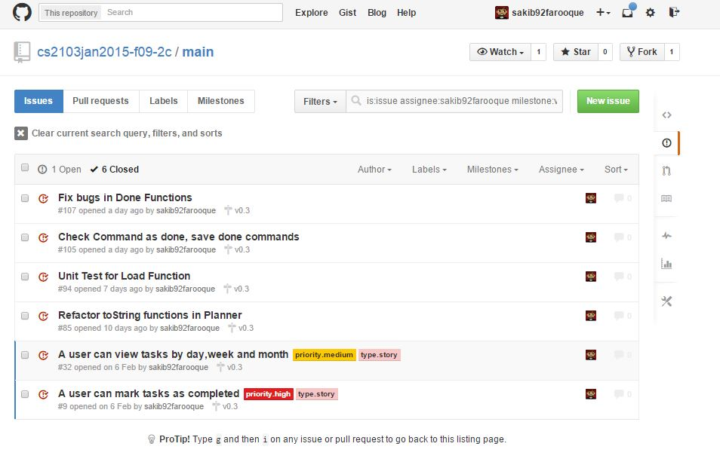

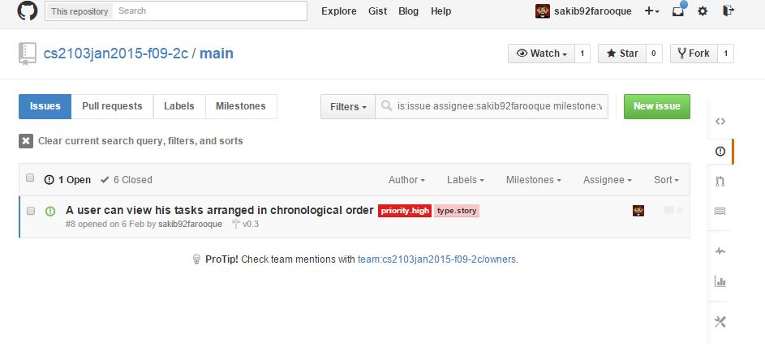[V0.3] Open Issues

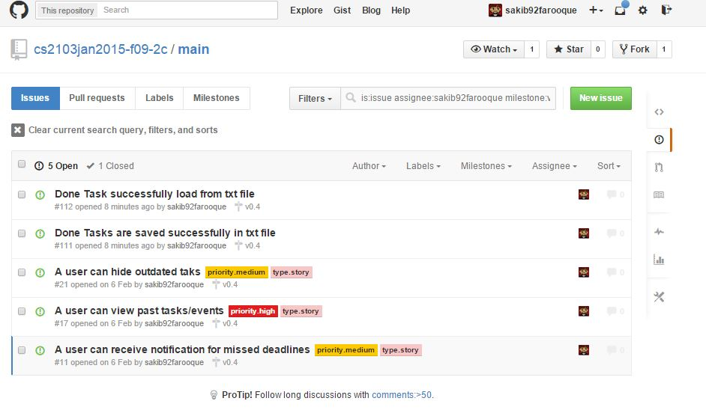[V0.4] Open Issues